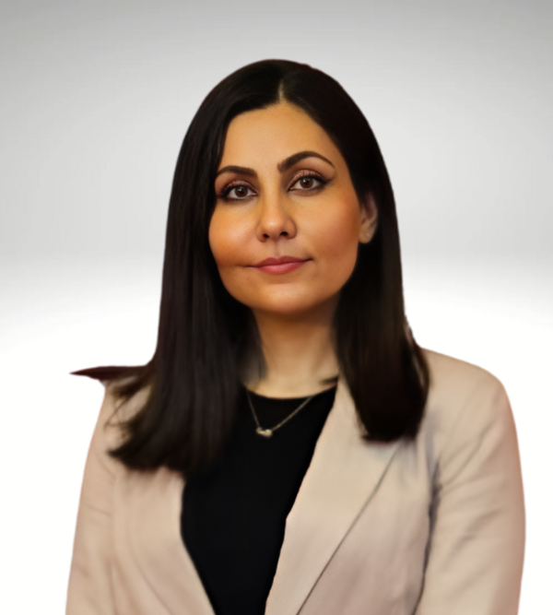 | Neda Heydarbegi  Web Developer | Digital Specialist
📞 0450 242 645
📧 wekteneda@gmail.com
🔗 LinkedIn: neda-heydarbegi
💻 Portfolio: nedah.net

Professional Summary
Results-driven Digital Specialist & Web Developer with over three years of experience in designing, developing, and optimizing responsive websites. Skilled in creating high-performing digital solutions with a strong focus on SEO, user experience, and data-driven marketing strategies. Proven ability to integrate web development with digital marketing, paid ad campaigns, and social media management to enhance brand visibility and drive conversions.

Core Competencies
• Web Development: PHP, HTML, CSS, MYSQL, Visual Studio Code.
• WordPress: Proficient in theme and plugin development, PSD to HTML/CSS.
• E-Commerce: Experienced in WooCommerce solutions.
• Responsive Design: Crafting seamless UI/UX across devices.
• API Integration: Expertise in integrating external APIs.
• SEO & Analytics: SEO strategies, Google Analytics/Search Console.
• Social Media Management: Content, scheduling, engagement, growth, analytics.
• IT Support Services: Troubleshooting, maintenance, optimization, assistance, security.

Professional Experience

MoonSun
Digital Marketing Specialist & CRM Manager
Sep 2024 – Present
- Designed and developed modern, responsive, SEO-friendly websites tailored to business needs.
- Implemented SEO and CRO strategies to improve search rankings and increase conversions.
- Managed Google Ads, Meta Ads, and PPC campaigns, optimizing performance for maximum ROI.
- Analyzed data using Google Analytics and Search Console to enhance user engagement.
- Led Odoo CRM system enhancements, streamlining workflows and improving customer interactions.
- Integrated Odoo CRM with marketing efforts, improving lead tracking and sales funnel efficiency.
- Developed and executed social media marketing campaigns to boost brand awareness.
- Collaborated with marketing, sales, and IT teams to align digital strategies with business goals.
- Optimized UI/UX design for better website engagement and conversion rates.
- Provided technical support and training on Odoo CRM, paid ads, and analytics tools.
- Developed and maintained custom web applications for security and scalability.

Web Tech Marketing
Digital Specialist & Web Designer
Dec 2023 - Present
- Website Design & Development – Designed and built responsive WordPress and Shopify websites optimized for speed, SEO, and user experience.
- UI/UX Enhancement – Improved website usability and design to enhance customer journey and conversion rates.
- SEO & Performance Optimization – Implemented on-page and technical SEO strategies to increase search rankings and organic traffic.
- Paid Ad Campaigns – Managed and optimized Google Ads and social media ad campaigns to maximize ROI and lead generation.
- Social Media Management – Developed and executed content strategies, managed social accounts, and increased engagement across platforms.
- E-commerce Optimization – Enhanced online stores with better navigation, product display, and checkout processes to increase sales.
- Analytics & Conversion Tracking – Monitored website and campaign performance using Google Analytics and A/B testing to improve conversions.
- Branding & Graphic Design – Created digital assets for websites, ads, and social media to maintain brand consistency.
- Technical Troubleshooting – Provided website maintenance, security updates, and bug fixes for smooth operation.

Care Services Australia
Digital Specialist & Web Designer
May 2022 - Feb 2024

- Engineered bespoke WordPress themes and plugins aligned with client requirements.
- Ensured harmonious design-functionality integration in collaboration with design teams.
- Partnered with marketing to align web development with organizational objectives.
- Managed, secured, and optimized 32 WordPress websites for peak performance.
- Converted PSD to Elementor.
- Troubleshot and rectified technical issues, facilitating smooth web operations.
- Delivered projects within tight deadlines, upholding superior quality standards.
- Offered comprehensive technical support, including client training and documentation.
- Executed website enhancements for speed, SEO, and implemented analytical tools.

EWRDC
WordPress Developer
Aug 2008 – Dec 2010

- Spearheaded the development of PHP and HTML solutions beyond WordPress scope.
- Oversaw seamless technical integrations with external services.
- Guaranteed compatibility across browsers, platforms, and devices.
- Crafted marketing materials to solidify brand identity.
- Monitored and maintained system performance, hosting, and databases.
- Innovated WordPress components for high-traffic sites, resolving design challenges.

Education
**Tabarestan Higher Education Institution (TU)**
Bachelor of Software Engineering
Graduated: 2010

